Assignment GameWorld

Date : 29-Apr-2017

By : Peter Nocker ([p.nocker@roc-teraa.nl](mailto:p.nocker@roc-teraa.nl)) & Benjamin Porobic ([b.porobic@roc-teraa.nl](mailto:b.porobic@roc-teraa.nl))

Hours : 20 hours (5 weeks, 4 hours a week)

Assessment : individual

Read the assignment carefully and ask questions if anything is not clear.

# Introduction

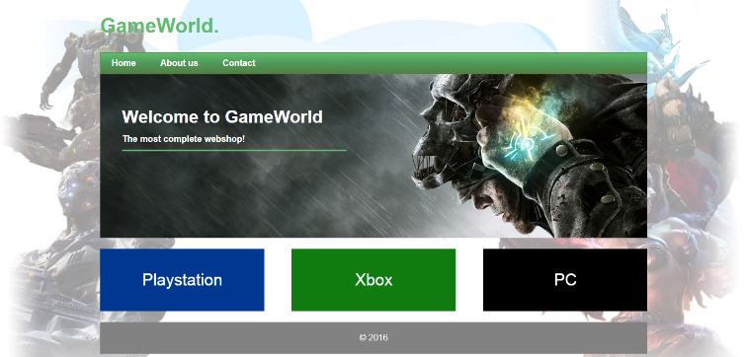At this moment there are around 100.000 ecommerce websites worldwide, this number is growing daily. In the following five weeks you are going to develop an ecommerce website for a video game store named, GameWorld. The owner of the store has a physical store and doesn’t have any online presence at this moment, as you can assume it is very important to be found on the internet.

Figure 1 Home page

The owner of the Store, Jerry, came to the conclusion that he needs an online store for his products (video games). Below is a list of requirements for the online store.

***note:*** every page consists of a logo (hyperlink to the homepage), navigation and a footer. The navigation and the footer usually stay the same on every page. But if you want to change something in the navigation or footer you have to edit every page separately. This is why you will use the PHP include method to place the navigation and footer on the page.

The first page where most of the visitors will land is the homepage. This is an important page for a website, because first impression counts! If the homepage is not appealing and/or unclear the visitor will click the back button and leave the website. To make the homepage appealing, Jerry came up with an idea of a banner on the homepage and on top of the banner a welcome text.

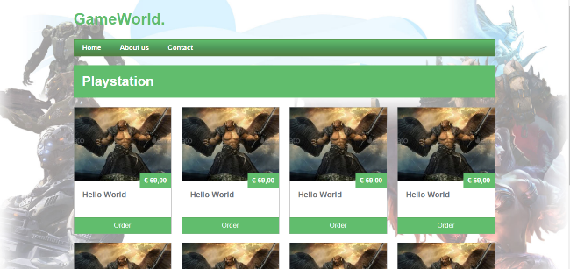

Beneath the banner are three links to different product categories (Playstation, Xbox and PC). When the visitor clicks on one of these links he will be redirected to a products page where all the products of this particular category are shown. These products are fetched from a database using PHP and MySQL.

Figure 2 products page

On the products page is the name of the category clearly visible. To make it even more clear you could change the color of the page per category.

Every product block consists of the following elements: image of the video game, price, name of the video game and an order button. When the order button is clicked the product will be placed in the shopping cart. The best solution is to place all the items in a PHP session. If you can’t develop the 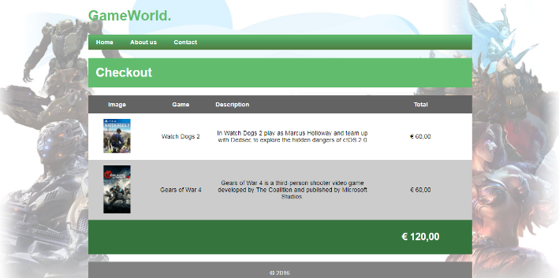checkout page with PHP sessions you can redirect the user to a static checkout page. The checkout page shows a list of products in the shopping cart.

Figure 3 Checkout page

Each item in the shopping cart contains an image, name of the video game, name of the video game and the price. The total price of all products together is shown at the bottom of the table.

Beside the ecommerce pages there are two other important pages, the about page and the contact page. The links to these pages can be found in the main navigation at the top of every page. The about page is a static page with content (text and images) about the game shop. The contact page consists of a contact form.

Prior knowledge

To successfully complete this assignment, it is necessary to have a basic understanding of HTML, CSS, PHP, (My)SQL.

# Must Must (grade 5,5)

* Logo in the top left corner with a hyperlink to the homepage
* Navigation
  + Visible on every page
  + Use HTML5-tag for the navigation
  + Navigation items: Home – About us – Contact
  + Insert navigation with PHP include
* Footer at the bottom of the page
  + Use HTML5-tag for the footer
  + Insert footer with PHP include
* Homepage banner and on top of the banner a welcome text
* Display minimum three product categories on the home page (Playstation, Xbox and PC)
  + Hyperlink to the products page using a GET parameter. Example: products.php?categoryId=1  
    On the products page you will use GET to retrieve the correct category ID. Each category (Playstation, Xbox and PC) has its own category ID in the database.
* Products page
  + Name of the category
  + All products are fetched from the database using PHP and MySQLi. Use a while or foreach loop to fetch data from the database.
  + Don’t create a different page for every category (example: playstation.php, xbox.php and pc.php) use only one page, products.php. Use the GET parameter to retrieve products from different categories.
  + Every product block consists of the following elements: image, price, name of the video game, order button
  + Display minimum 6 products per category
* Static checkout page with a minimum of three products in the shopping cart. Each item in the shopping cart contains an image, name of the video game, price. Total price of all the products together is shown at the end of the checkout page.
* Place on the about page dummy content (text and images) and on the contact page a static contact form. Use headers, paragraphs and think about white space.
* Upload your project on a live webserver!
* Upload your project files to GitHub

# Should should (grade 5,5 – 8,5)

* Organize files neatly in folders
* Logical and consistent names for variables, id’s and classes
* Indent code with tabs
* Make a separate file for the database connection and use PHP include to include this file on necessary pages.
* Use PHP Sessions to store and retrieve products in a shopping cart
* Use hover effect on hyperlinks and buttons
* When the visitor clicks on a specific category the colors of the elements on the product page should change.
* Working contact form with PHPmailer or Mail function

# Could should (grade 8,5 – 10.0)

* Use checkboxes on the product page to store multiple products at once in the shopping cart
* Make a product detail page with multiple images of the product, name of the product, short description, possibility to add more than one product in the shopping cart, order button.

# Won’t

* Use an open source or commercial ecommerce solution!
* Use a template or a front-end framework like bootstrap!

Tips, Resources

* Use classroom examples and PowerPoint sheets from N@tschool.
* Make backups: external hard drive or cloud storage
* Upload your finished assignment in N@tschool. Use Winrar or 7-zip to pack your files
  + Only .7zip or .rar file extension allowed
  + Filename: ***firstname_lastname_gameworld.rar***
  + Filename example: john_doe_gameworld.rar
* PHP and MySQL:
  + <https://www.w3schools.com/php/php_mysql_connect.asp>
  + <https://www.w3schools.com/php/php_mysql_select.asp>
  + <https://www.w3schools.com/php/php_looping.asp>
  + <https://www.w3schools.com/php/php_sessions.asp>
* HTML:
  + <https://www.w3schools.com/tags/tag_nav.asp>
  + https://www.w3schools.com/tags/tag_footer.asp
  + <https://www.w3schools.com/cssref/pr_class_float.asp>
  + <https://www.w3schools.com/html/html_forms.asp>
* Online courses:
  + www.udacity.com
  + [www.codecademy.com](http://www.codecademy.com)
  + [www.freecodecamp.com](http://www.freecodecamp.com)
* Work together if necessary, but **do not copy**. **In case of fraud, you have to create your own assignment with the same techniques as this one. You have to discuss this with your teacher!**

# Assessment

***Note:*** If you hand in the assignment a week after the deadline 0,5 of your total grade will be subtracted. See the study guide for the deadline.

